Name: Ali Albayrak

Student Id: P304320

Portfolio 3.1

Vocabulary

Parsing: Dividing a string into a set of sub-strings.

StringBuilder: A class that represents a string-like object, but unlike a string can be modified using methods such as appends.

Split: A method inside the String class that parses a string by a specified character or, if unspecified, by spaces.

1.Imagine that you arrive at school and your teacher declares that it is backwards day, and anything you request to say to her must be written down in reverse. You decide to write a method that takes in a string and generates and prints the string backwards to the string so you may communicate with your teacher. Complete the method below so it works as intended.

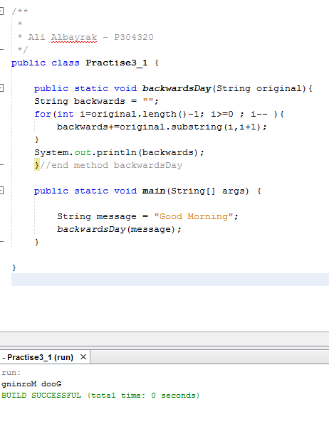

2. Would the method you completed in problem 1, assuming it works properly, also work for converting the backwards messages that the teacher gives you into forwards, readable messages? Why or why not?

Yes, It can. Because it is dividing the message letter by letter and converts it to new string by order. So it does not matter at all.

3.What is the major difference between making modifications to a String and a StringBuilder?

We cannot make any modifications to a String once its created. The methods that we are using to modify a string, create a new string in the memory. So when we try to modify it, it uses more memory. But, when we use StringBuilder, we can modify it. Because of that , It has low consumption of memory.

4. Complete the following method so that it works as intended. The below method takes in a String as a parameter and returns the reverse of the String.

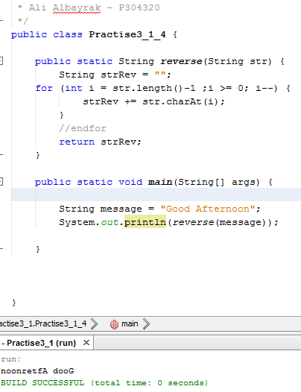

5. In some situations it is easier to use a StringBuilder instead of a String. Create a program that does the same as Q4 (reverses some text) but use a StringBuilder and one of its methods to accomplish the task.

